Australian World War 1 Army Identity Disc – Pte W.H. Amy 711
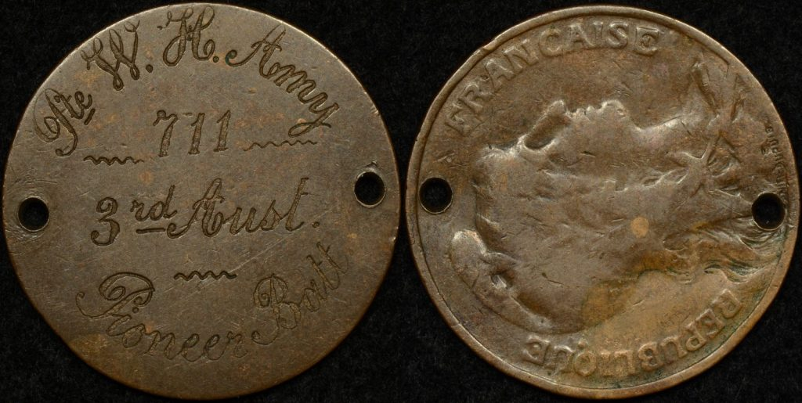
Shown is an unofficial Australian World War 1 identity disc fashioned from a French 10 centime. It is holed twice and the reverse has been skimmed off. Neatly engraved into the skimmed surface is:
Pte W.H. Amy
711
3rd Aust
Pioneer Batt
The inscription appears to be proffessionally engraved, suggest that perhaps it was done “behind the lines” by a skilled craftsperson. It’s possible to date the ID disc to a relatively neat 6 month period from July to December 1918 when Amy served with the 3rd Pioneer Battalion.
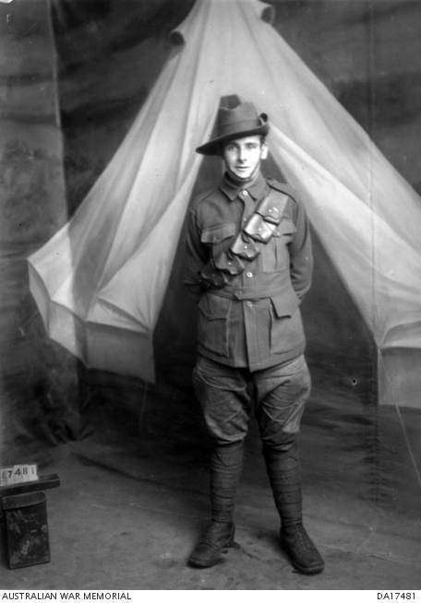
William Henry Amy 711A (Image courtesy Australian War Memorial)
William Henry Amy was born in 1899 to parents John and Emily. In 1916 William was given permission by his father to enlist into the AIF as described by a letter in his military records. He enlisted in the AIF in Yarraville, Victoria in March 1917 aged 18 years and 6 months and listed his occupation as Munitions Worker. Sometime in 1917 William married his first wife, Ida Bamford and she is listed as his next of kin on his enlistment papers.
Upon enlistment Amy was given the service number 711. He was taken into the Royal Park Recruits Battalion and about 5 weeks later transferred to the Machine Gun Depot in Seymour, Victoria as part of the 15th Machine Gun Company of the 13th Reinforcement Battalion . On the 21st of July 1917 he embarked on A29 HMAT “Suevic” and was immediately checked into the ship’s hospital suffering from Venereal Disease. Amy spent 19 days in the ship’s ward and landed in Liverpool, England on 26 August 1917.
The next 5 and half months saw him trained in the 15th Training Battalion, the 59th Battalion, and the 4th Division Signal School. Finally in mid February 1918 he reinforced the 39th Battalion before being sent to France on 19 February 1918 and being taken on strength on the 23rd of the same month. In July he was transferred to the 3rd Pioneer Battalion which dates the ID disc to a 6 month period at the end of WW1. At this point he was re-allocated the regimental number 711A as there was probably already a soldier to whom 711 had been allocated. Five days later he was taken onto the strength of the 4th Pioneer Battalion in the field. Amy’s records indicated that he was wounded in action on 23 August 1918 The War Diary of the 3rd Pioneer for the 23rd of August, 1918 indicates that they supported the left flank of the 1st Australian Division in an attack south of the Somme. The 3rd Pioneer Battalion captured the village of La Neuville the same day. It seems likely that Amy was wounded in that action which is described in the war diary as “an exceedingly successful operation”.
The remainder of William Henry Amy’s war service saw him admitted to various hospitals in France and England listed as ‘sick’ before finally being admitted to yet another hospital in Chatham with tuberculosis in early 1919. Amy returned to Australia on 21 February 1919 arriving home in early April the same year.
William and his wife Ida welcomed three daughters after WW1 before his wife’s untimely death in 1928. He married the next year in 1929 to Nellie Smithwich, that marriage saw no children and ended in divorce in 1937. Amy remarried again in 1938 or 1939 to Emma Finlay. In 1942 Willam Amy joined the Australian Military Forces and listed his address as 13 Bell St. Coburg, Victoria. He was posted to the 24th Battalion of the Volunteer Defence Corps in 1943 on a part time basis and was discharged in early 1945.
We have been unable to locate any other information about William Henry Amy after the conclusion of World War 2. He passed away in April, 1975 aged 76 in Heidelberg, Victoria and his grave can be found in Fawkner Memorial Park, Fawkner, Victoria.
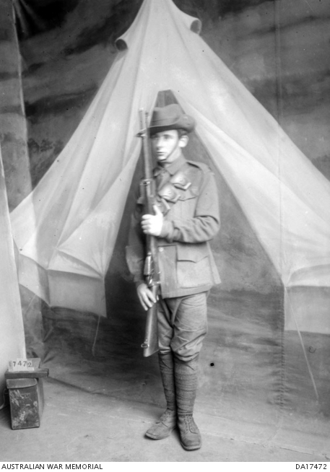
William Henry Amy 711A (Image courtesy Australian War Memorial)

