Australian identity discs: a record of recognition
By Ethan Devereux-Phillips · June 5, 2025
The First World War saw the mobilisation of millions of servicepeople across the Entente and Central powers, including some 416,809 enlisted Australians. For militaries worldwide this posed a significant logistical challenge; how does a nation organise and monitor so many soldiers, sailors, airmen and nurses accurately and efficiently. As the true horrors of the chaotic, modern battlefield revealed themselves, the situation was further compounded by the need to identify the vast number of casualties and fatalities, some of whom lay unrecoverable for months or years after their deaths. Enter one part of the solution – identification discs!
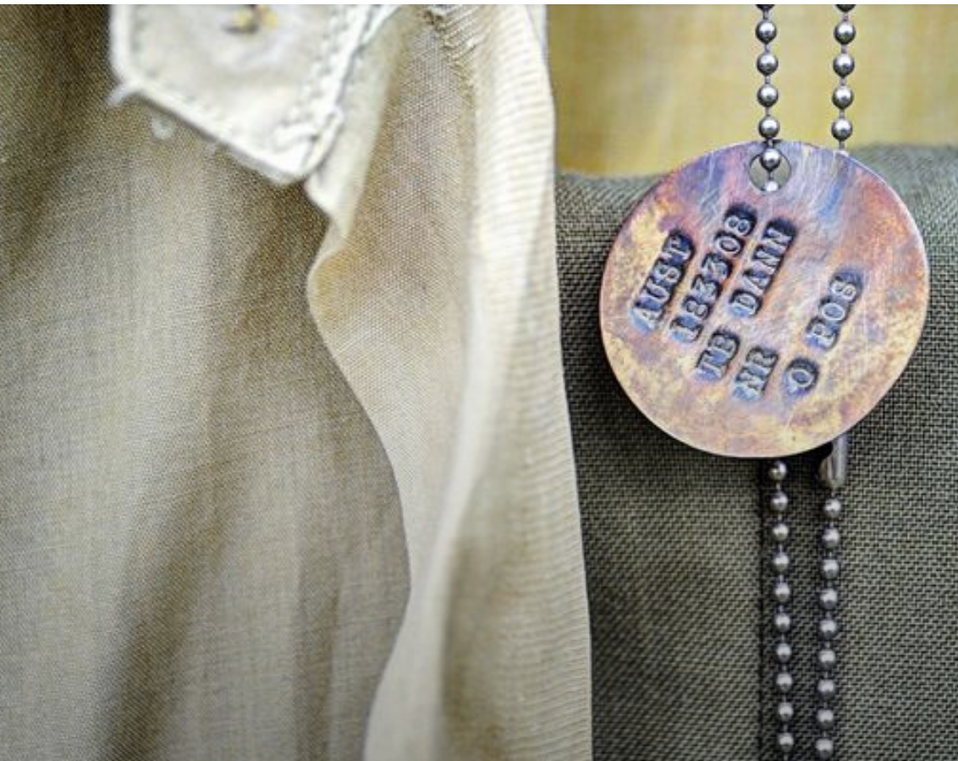

Early Identification Systems
Identity discs (aka ‘dog tags’) predate The Great War, having been first officially adopted by the Germans some 44 years earlier. Conflicts in the 19th century, such as the Second Schleswig War of 1864, had seen large casualties, and social expectations at the time demanded that individuals be identifiable on humanitarian grounds. In particular, it was deemed necessary to identify the unconscious wounded and deceased, the latter being interred in marked graves and their families informed. To this end, Erkennungsmarke (literal translation: recognition labels) were trialled in 1866 before being deployed in the Franco-Prussian war of 1870-71. Their success was such that all militaries were required to issue identifying marks to combatants under the Geneva Convention 1906, article 4.
'Art. 4. As soon as possible each belligerent shall forward to the authorities of their country or army the marks or military papers of identification found upon the bodies of the dead, together with a list of names of the sick and wounded taken in charge by him.' Geneva Convention on Wounded and Sick, 1906.

World War I
Britain, and subsequently the Commonwealth, adopted a system of identity discs in 1906, known as the Pattern 1907. About 42mm high and 32mm wide, these small aluminium discs were worn around the neck and recorded a soldier’s name, unit, service number and religion. At the start of the First World War, these remained standard-issue and each member of the Australian Imperial Force received one.
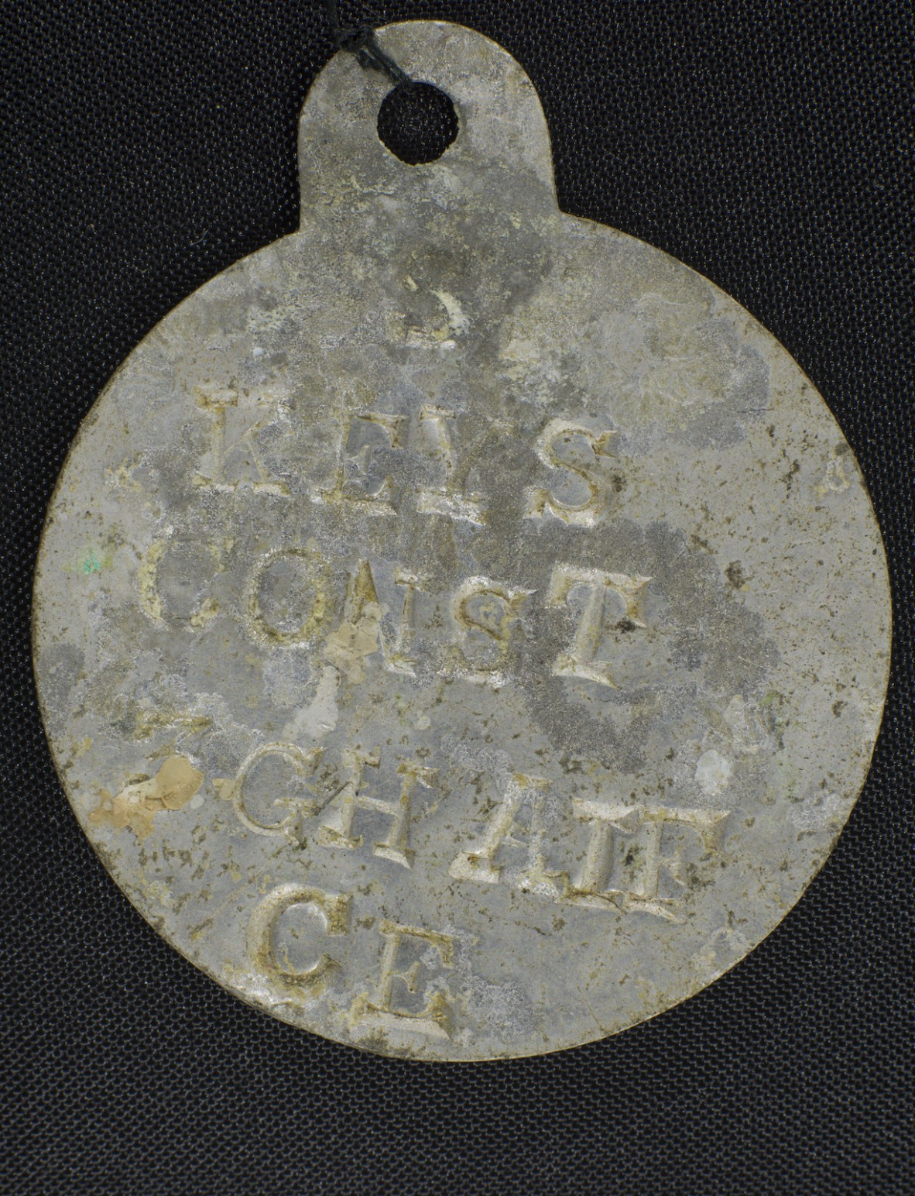
A 1907 pattern identity disc issued to Queensland Nurse Constance Mabel Keys in WWI. It reads 'KEYS CONST 3 GH AIF CE.'
Such a disc belonged to Sister Constance Mabel Keys, who served in the Mediterranean and Western Front. We can still make out her name, her assigned unit as the 3rd Australian General Hospital (3 GH AIF) and her identified religious denomination as Church of England (CE). We can see that Constance’s details were stamped, although other discs were engraved. Additionally, she has no listed service number – likely because she was a nurse. Commissioned officers likewise did not have a number listed.
If an Australian was found deceased, their disc and paybook were to be taken from the body to the unit officer for record. While this provided a means to record individual casualties it had a glaring issue in that it left no identification with the physical remains for later burial teams. This method also assumed that the tag would be found intact with the body; an ideal often thwarted by dismembering artillery barrages. Many soldiers attempted to rectify the issue by purchasing identification bracelets at their own cost – a practice which dated back to at least the American Civil War. These were purchased from jewellers or produced in the trenches by soldiers themselves, resulting in a variety of styles.
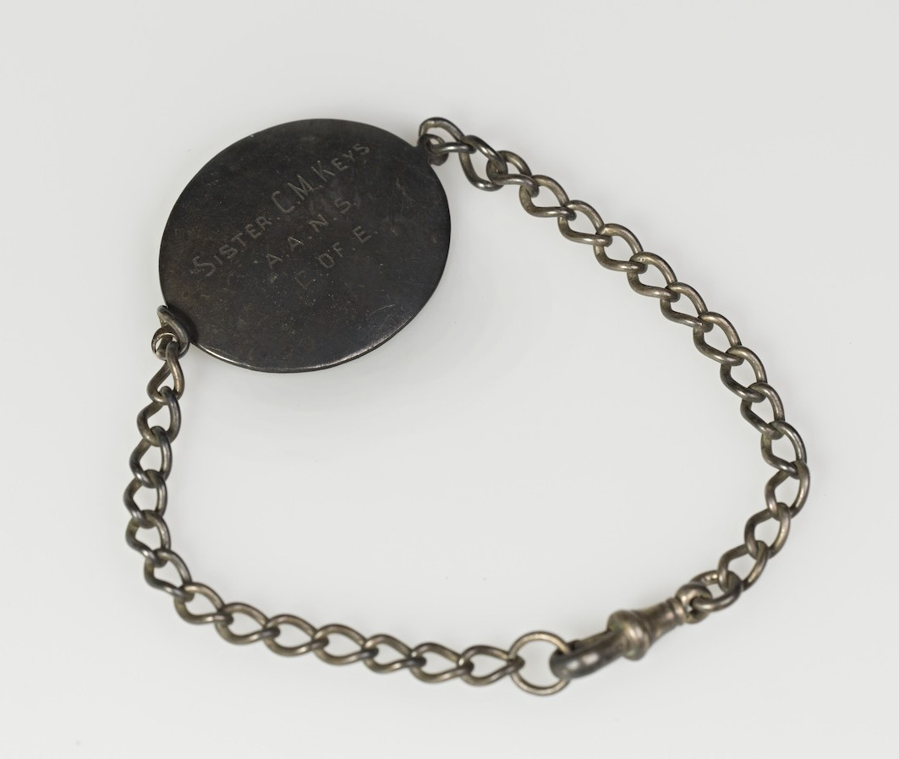
A personal identity bracelet belonging to Constance Mabel Keys. It reads 'SISTER C.M. KEYS A.A.N.S. C. OF E.' A hallmark on the reverse indicates it is sterling silver.
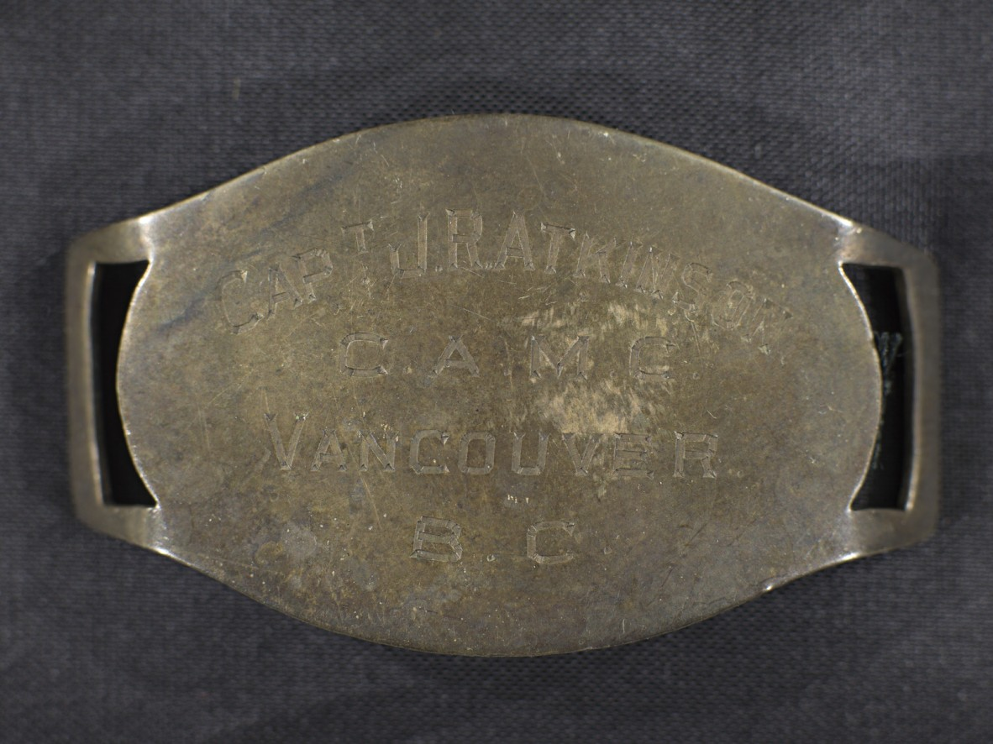
An identity bracelet belonging to Captain J.R. Atkinson of the Canadian Army Medical Corps. It reads 'CAPT J.R. ATKINSON C.A.M.C. VANCOUVER B.C.' A hallmark on the reverse indicates it is silver, produced in Birmingham 1917.
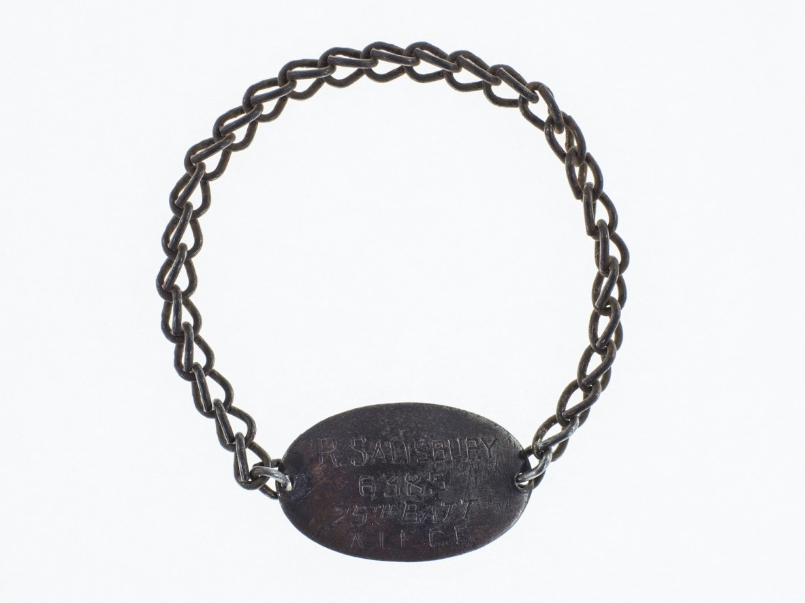
An identity bracelet belonging to Robert Salisbury of the 25th Battalion. It reads 'R. SALISBURY 6385 25TH BATT A.I.F. C.E.'
The German army introduced their solution to the one-disc problem in late 1916, adopting an oval zinc plate with perforations running through the centre. A soldier’s details would be stamped into both halves and the tag would be worn around the neck via a cord through the 2 upper holes. If a soldier’s body was discovered, the lower half would be snapped off and taken back for record, while the upper half would remain for later identification.
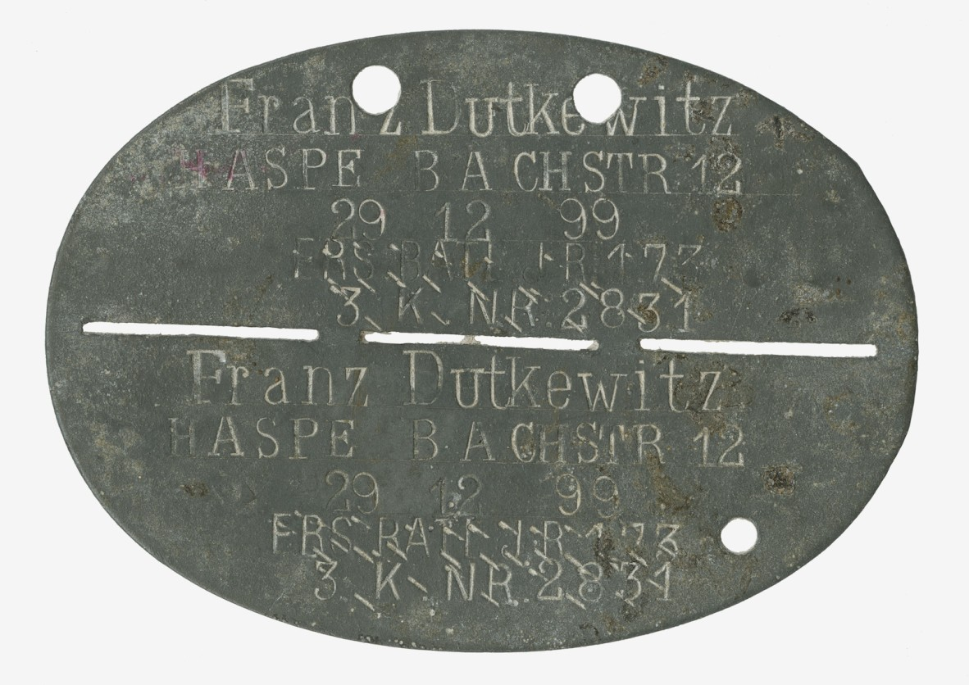
A 1916 pattern German 'Erkennungsmarke' belonging to Franz Dutkewitz. The likely translation indicates he was born December 1899, resided in Hagen-Haspe, North Rhine-Westphalia, and served with the Reserve Battalion, 173rd (9th Lotharingian) Infantry Regiment. The 173rd was scratched when he was reassigned to the 67th (4th Magdeburg) Infantry Regiment.
The Commonwealth also adopted a two-disc system in late 1916, being issued to Australian troops in France from November. This featured a hexagonal ‘Disc, identity, No. 1, green,’ to which was strung a circular ‘Disc, identity, No. 2, red.’ Like the German system, the red disc was to be taken from a body and the green left behind. Unlike the German discs however, the Commonwealth discs were manufactured from a compressed fibre which quickly decomposed in the conditions on the Western Front.

World War II
The No. 1 and No. 2 discs remained in service during the interwar years and into the start of the Second World War, with a few updates. Units were no longer listed for security reasons. After all, if the enemy were supposed to be collecting your tags too, you wanted to give them as little intelligence as possible. However, a piece of information necessary to confer to friend and foe alike was one’s blood type, which was listed according to the Moss system and Landsteiner ABO system. Service numbers for officers were added too, as these were issued during this period.
Despite these updates, the discs still had their issues. The compressed fibre that had deteriorated quickly on the Western Front fared no better in the wet, tropic environments of the Pacific where most Australian forces were deployed from 1942. After soldiers complained of being unable to identify their dead, 16,000 stainless steel discs were sent to New Guinea in March 1943. Several thousand more were sent to the front afterward, and by 1944 they became standard issue. These metal discs were identical to those issued to Royal Australian Air Force (RAAF) personal, who had the pragmatism to transition some years prior.
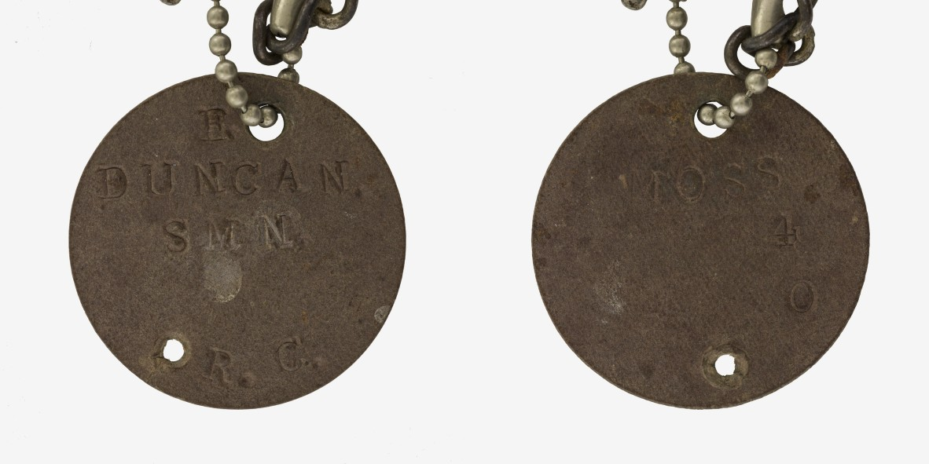
The front and back of a WWII Royal Australian Navy identity disc issued to Ernest Duncan. It reads 'E. DUNCAN. SMN R.C. MOSS O4.'
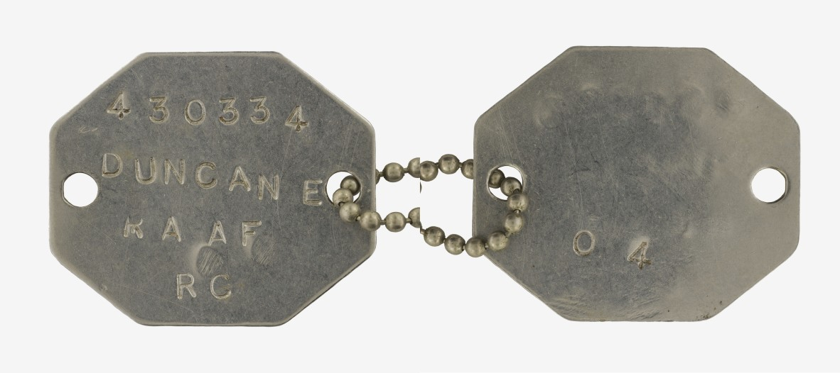
The front and back of a hexagonal WWII Royal Australian Airforce identity disc issued to Ernest Duncan. It reads '230334 DUNCAN E RAAF RC O4.'
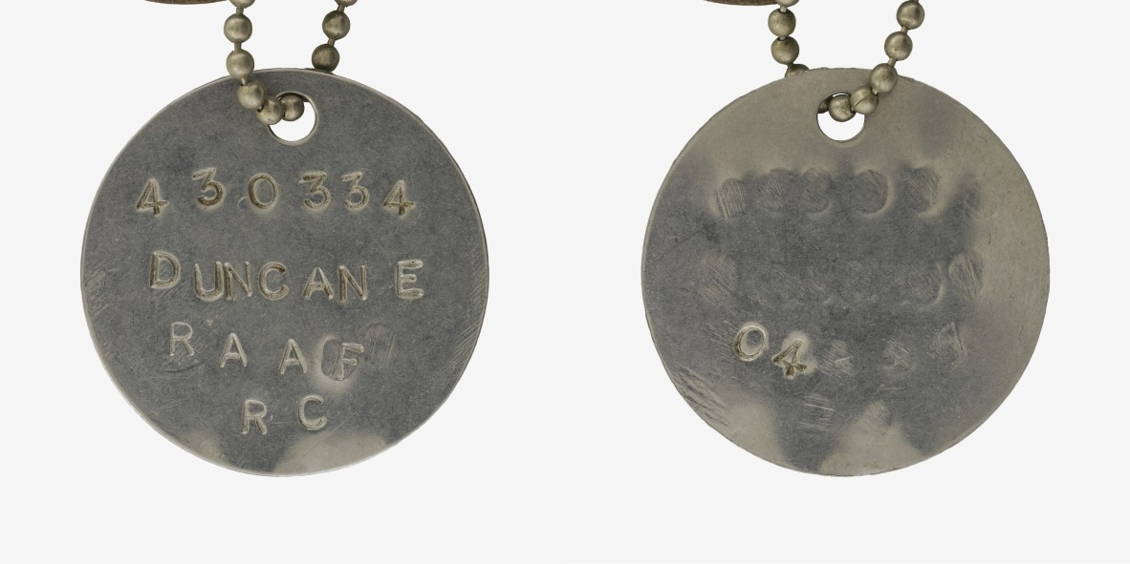
The front and back of a circular WWII Royal Australian Air Force identity disc issued to Ernest Duncan. It reads '430334 DUNCAN E RAAF RC O4.'
Ernest Duncan served in the Civilian Military Force, Royal Australian Navy (RAN) and RAAF from 1941 until 1945. His collection holds an example of a RAN disc from the time, which lists his role as a seaman (SMN), religious denomination as Roman Catholic (RC), and blood type as O (Landsteiner) and 4 (Moss). The Navy seemingly did not learn the lessons of the Army, as they continued to issue just one compressed fibre disc. Contemporaneous accounts and photographs indicate this was rarely worn by sailors anyway. Ernest’s RAAF discs record the same information as his RAN kit, bar the addition of a service number. His discs were engraved, which was standard amongst the RAAF in contrast to the Army’s use of stamps.

Post-War and Today
Immediately after World War Two, Ernest served with the United Nations Relief and Rehabilitation Administration (UNRRA) in China, provisioning food, clothing and shelter for the local population. There he met Valda Markham, who was also serving in UNRRA, and the pair married in 1947. Although civilian, they both wore stainless steel discs which listed their religion, blood type, UNRRA number, name and next of kin.
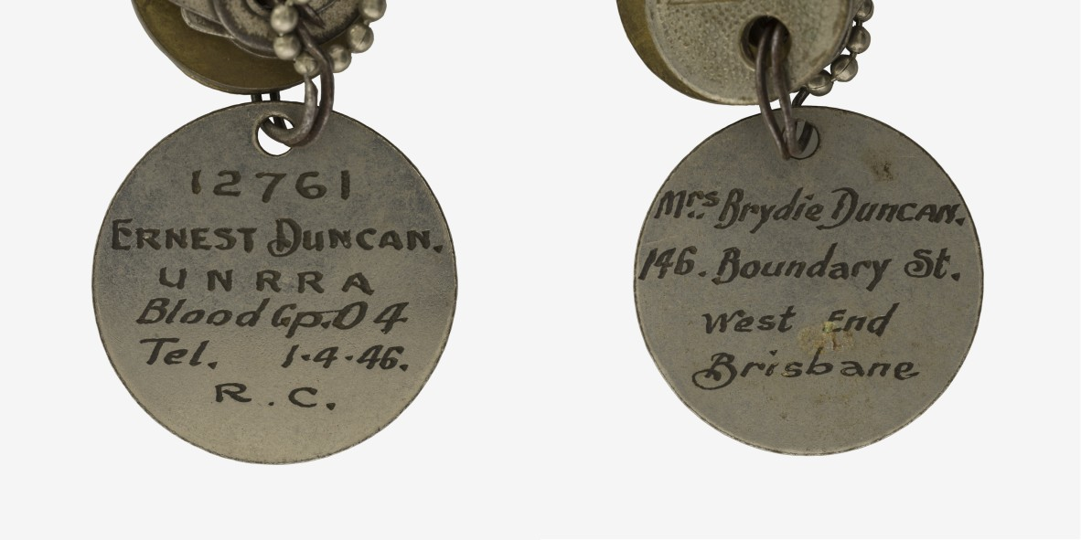
The front and back of an identity disc worn by Ernest Duncan during his service with UNRRA. He also owned a second disc, as was now the custom. Note this disc states a next of kin, unlike Ernest's military-issued kit.
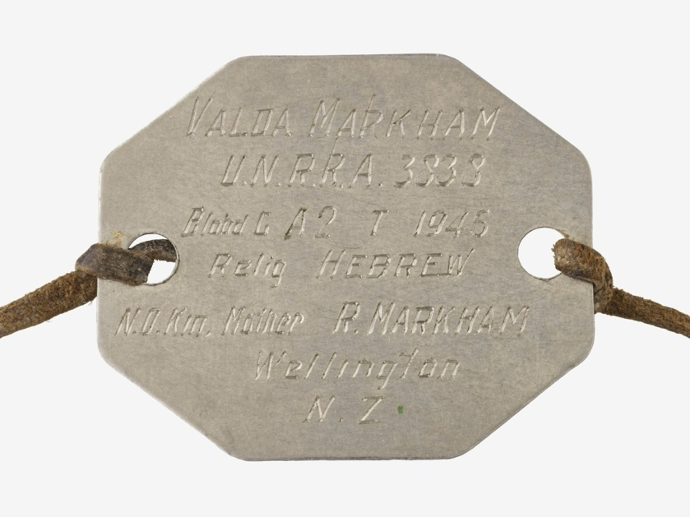
A hexagonal metal identity disc worn by Valda Markham during her service with UNRRA. Unlike regular military discs, it lists her next of kin.
Despite their shortcomings, identity discs improved the ability of Australians to recognise mates taken to Casualty Clearing Stations or killed in action – oftentimes providing the only method of identification. In turn, this ensured a greater portion would be buried in marked graves, which was a matter of great anxiety for many combatants and their loved ones alike. For families back home, the discs provided some surety about the loss of their loved ones. A conclusive identification made the grief a little easier to bear, and was usually preferable to ‘Missing in Action,’ which left people hoping their kin would return even decades after the war.
Today, Australian servicemen and women continue to be issued with metal identity discs, referred to as 'Number 1 Tag (octagonal)' and 'Number 2 Tag (circular).' Bar the addition of the national identifier ‘AUST’ the design would be just as familiar to a soldier in 1945 as today, and for good reason. The inexpensive, metal two-disc system is a simple solution which functions just as well on today’s battlefields as those of the past.
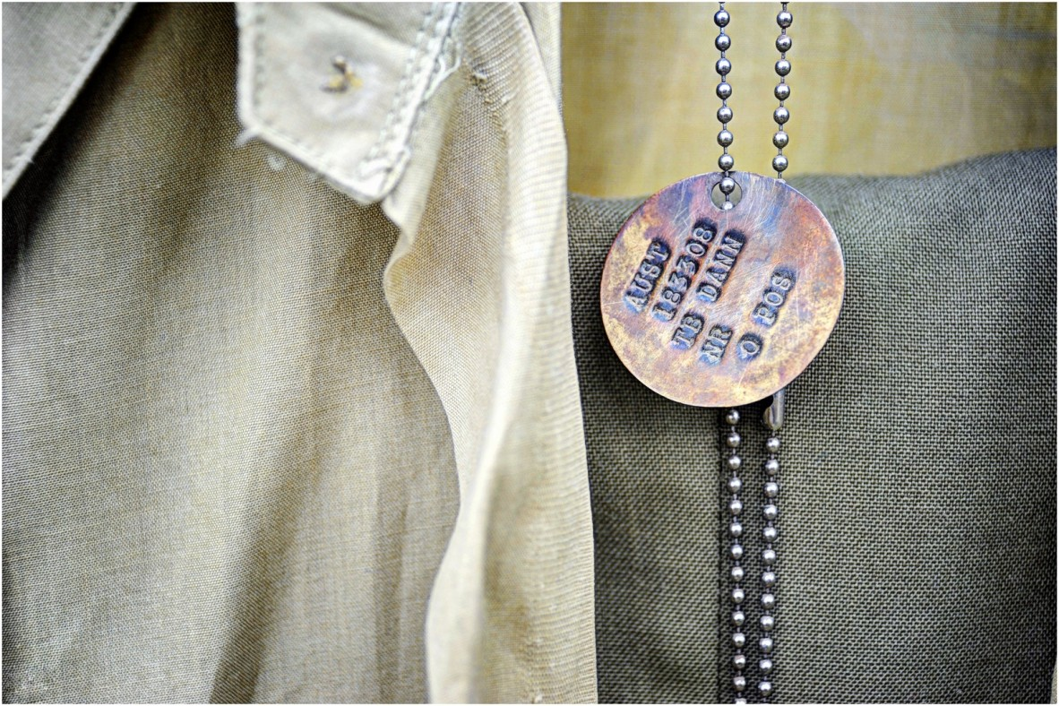
A modern circular identity disc which reads, 'AUST 183308 TB DANN NR O POS.' It was part of a collection of uniforms which were covered by mud during the Bundaberg Flood, hence the colouration.

References and further reading:
Ashbridge S and O’Mara D (2021) The Erkennungsmarke: the humanitarian duty to identify fallen German soldiers 1866-1918, Journal of Conflict Archaeology, 15:3, p. 192-223.
Ashbridge S and Verdegem S (2020) Identity discs: The recovery and identification of First World War soldiers located during archaeological works on the former Western front, Forensic Science International, 317.
Australian War Memorial (2023) Australian identity discs of the First World Waropen_in_new, Australian War Memorial Website, accessed 19 February 2025.
International Committee of the Red Cross (1906) Convention for the Amelioration of the Condition of the Wounded and Sick in Armies in the Field. Geneva, 6 July 1906.open_in_new, International Humanitarian Law Databases Website, accessed 19 February 2025.
O’Mara D (2020) Identifying the Dead: a Short Study of the Identification Tags of 1914-1918open_in_new, The Western Front Association Website, accessed 19 February 2025.
Rutherford D (2015) Understanding Australian Identity Discs Part 2: Second World War, Royal Australian Navyopen_in_new, Australian War Memorial Website, accessed 19 February 2025.
Rutherford D (2015) Understanding Australian Identity Discs Part 3 : Second World War, Armyopen_in_new, Australian War Memorial Website, accessed 19 February 2025.
Rutherford D (2016) Understanding Australian Identity discs part 4: Second World War, Royal Australian Air Forceopen_in_new, Australian War Memorial Website, accessed 19 February 2025.
Terrett L and Taubert S (2015) Preserving our Proud Heritage: The Customs and Traditions of the Australian Army, Big Sky Publishing.

