FBI Raids Georgia Election Office as Trump Expands Attack on Democracy
-Hafiz Rashid
Wed, January 28, 2026 at 12:13 PM CST
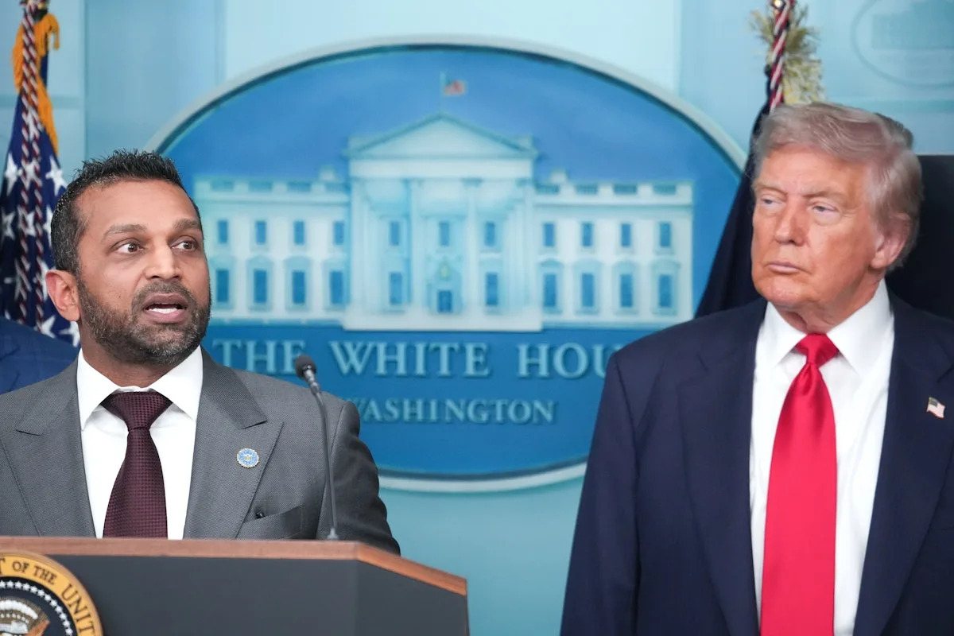
The FBI is carrying out a search warrant at an election office in Fulton County, Georgia, related to the 2020 election.
The search is taking place at the Fulton County Elections Hub & Operations Center, the FBI said Wednesday. A spokesperson in the Atlanta office said the bureau was conducting “court-ordered activity” at the election office, without providing additional details.
The building has served as storage space for election equipment, as well as office space for multiple Fulton County agencies, since it opened in 2023. Atlanta TV station WSB-TV reports that the FBI is seeking to take custody of Fulton County election ballots from the 2020 election.
The Justice Department sued the Fulton County Board of Registration and Elections last month, claiming that the office hadn’t complied with a subpoena demanding “used and void ballots, stubs of all ballots, signature envelopes, and corresponding envelope digital files from the 2020 General Election in Fulton County.”
Trump and his supporters continue to claim that he won the 2020 presidential election and that it was stolen from him, alleging widespread fraud in places like Georgia. Fulton County District Attorney Fani Willis pursued a criminal investigation against Trump and 18 allies over the attempt to overthrow election results in her state, but she was disqualified from the case in 2024 over conflict of interest concerns, and the case was dismissed last year.
This story has been updated.

