IDENTIFICATION DISCS IN WW1
August 1, 2015
(Source: Royal Montreal Regiment Foundation)
Sunday, August 1, 1915
Trenches – Ploegsteert
The Battalion War Diarist wrote nothing for this day: “In trenches at Ploegsteert (from July 29th)”[1]

THIS DAY IN RMR HISTORY: “On August 1st Major Gault McCombe, who had been wounded at the Second battle of Ypres, returned to the Battalion and took over command of No. 3 Coy. Enemy grenade throwers and rifle grenadiers were active on this date, the Battalion losing several men wounded, among these being Sergt. Jock Walker, in charge of the Battalion snipers.” [2]
Michael Dorosh on his extensive website canadiansoldiers.com has written about identification discs issued in WWI.
Identification Discs: “The Canadian soldier had a variety of official methods of identification; these were necessary for security reasons in addition to identification.
Identification Discs – First World War: ID Discs, sometimes called “dog tags” though this seems to be more of an American term, were the primary means of identifying soldiers who had become casualties. Identification discs were introduced into the British Army in approximately 1907 (when it is first mentioned in official documents). It consisted of a single aluminium disc, with a 42-inch cord. On the disc was stamped Regimental Number, Name, Rank, Regiment and Religion. Discs were to be marked locally, with 1/8-inch steel stamps. By May 1907 the requirement to include rank was abolished. An amendment to order in Apr 1908 permitted units to inventory discs with the regiment’s name already stamped on it.
Up until early 1914 the standard Identification Disc in British and Canadian service was made of Aluminium. A red fibre disc (described as “non-ferrous, fibre…which resembled linoleum”) appeared in the Priced Vocabulary replacing the Aluminium one by Aug 1914. Aluminium discs were quite common, especially in Commonwealth forces, until after 1915.
The fibre discs were marked identically to British discs, with the addition of CANADIANS or the abbreviation CDN. Some discs were stamped with half the information on one side, half on the reverse.
In April 1916, Army Order 3827 specified that each officer and soldier was to be issued two identity discs.
- Disc, Identity, No. 1, Green
- Disc, Identity, No. 2, Red

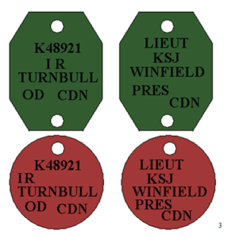
The green disc, octagonal in shape, was to be worn around the neck suspended on a cord. The second, red, disc, was to be suspended on another short length of cord, itself suspended from the first cord. The desire was to have one disc remain with the body in the event the soldier was killed. Soldiers already in possession of discs were issued with 6 inches of cord and ordered to adjust their tags in the prescribed manner. No orders were immediately issued on the reasoning for the new tags, and an amplification had to be issued in Oct 1916, specifying that the green tag was to be buried with fatal casualties. In the event a body could be reached but not brought back for burial, the red disc was to be removed to allow for proper notification of unit and next of kin, with the upper disc remaining with the body to ensure proper identification when the body was in a position to be recovered.”

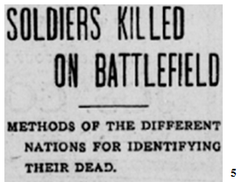
“When a German soldier falls in battle he is identified by a little metal disk which he carries. This disk bears a number, and this number is telegraphed to Berlin. There the soldier’s name is determined. This system is as effective as everything else connected with the German Army.
The British use an aluminum disk that contains, besides marks of identification, the soldier’s church affiliation. The Japanese system is similar, each soldier wearing three disks, one around his neck, another on his belt and the third in his boot. The Russians wear a numbered badge.
The United States army uses a cloth tab woven into the shoulder strap of the tunic. The French use identification cards stitched inside the tunic. The French once made use of metal identification badges, but these proved an irresistible attraction to the savages whom the French faced in Africa, so the cards were substituted. Austria still uses a badge of gun metal in the form of a locket with parchment leaves inside.
Turkey has no identification badges for her soldiers. Edhem Pasha once explained this omission as follows: ‘A dead man is of no use to the Sultan. Why therefore trouble with him?’ (The Baltimore American).”
[1] War Diary, 14th Canadian Battalion, The Royal Montreal Regiment, August 1, 1915. Library and Archives Canada, Ottawa http://data2.collectionscanada.ca/e/e044/e001089768.jpg
[2] R.C. Featherstonhaugh, The Royal Montreal Regiment 14th Battalion C.E.F. 1914-1925, Montreal, The Gazette Printing Co., Ltd., 1927, pp.65-66.
[3] Michael Dorosch, “Identification Discs – First World War,” http://www.canadiansoldiers.com/equipment/personal/id.htm
[4] Ibid
[5] “Soldiers Killed on Battlefield,” The Quebec Chronicle, Quebec City, Thursday, July 29 1915, pg. 3, col. 3.
[6] Ibid

