Mystery of the Alexandra Forest Unveiled......
Jul. 23rd, 2008 Retrospect
By Para-sakura
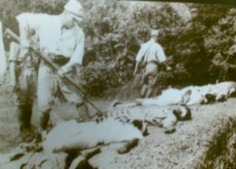
In the blog entry posted on the 25th June 2008 (http://globalsoundis.livejournal.com/5978.html), the author described the investigation team's paranormal encounters within the premise of the Alexandra Hospital. While paranormal activites were expected from within the hospital compound, which had been the site of ruthless carnages by the Japanese soldiers during World War II, the GSIS clairvoyants were particularly drawn to a forest situated behind the hospital's mortuary which they perceived to be "more haunted" than even the hospital building itself.
Established in 1938, Alexandra Hospital served as the principal hospital for the British in the Far East and was known as the British Military Hospital. At that time, it was the largest and best-equipped military hospital in Britain's "Far East Command." However, on the 14th Feb 1942, the Japanese troops invaded the hospital and mercilessly bayoneted countless patients, doctors and nurses. British officers displaying the red cross flag were not spared from the bayonets and bullets. One Japanese platoon even charged into the operating theatre and knifed the helpless patients to a bloody death. Bodies were strewn across the hospital ground by the time the Japanese left the place.
On the following day, a group of more than 200 surrendered hospital staff, army officers and men were assembled by the Japanese soldiers and herded along the railway track behind Alexandra Hospital. According to John Patridge, the author of "Alexandra Hospital: From British Military to Civilian Institution 1938 to 1998", the men walked past the "burning Normanton oil tank, through a drain tunnel under the railway embankment to the Ayer Rajah Road, then to a row of buildings a quarter of a mile from the hospital.......Those who fell along the way were bayoneted and left for death."
So where were these Normanton oil tanks?
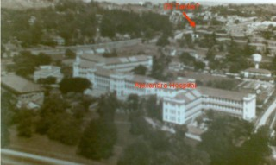
A picture of Alexandra Hospital taken from somewhere near the junction between
Alexandra Road and Queensway. Note the presence of oil tank-like gigantic
barrel structure just behind the hospital buildings (from "Alexandra Hospital: From
British Military to Civilian Institution 1938-1998")
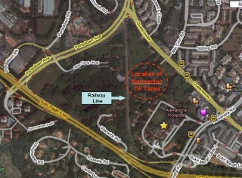
An aerial map of the Alexandra area, showing the location of the hospital
and speculated site of the Normanton Oil tanks (marked by red circle).
(from sg.shownearby.com)
In a pre-war picture of Alexandra Hospital, cyclindrical structures could be seen right behind the hospital building (indicated by red arrow in picture above). When we looked at the current map of the Alexandra, the cyclindrical structures appearred to sit right next to the railway line behind the hospital building. As such, these cyclindrical structures could well be the Normanton oil tanks that the surrendered men walked past under the orders of the Japanese. Coincidentally, the the secondary forest with reported paranormal activities maps to somewhere adjacent to where the Normanton oil tanks were once located..
So what happened to the 200 or so men who were made to cross the railway line?
According to John Patridge, ".....the prisoners were packed into three small rooms, the biggest of which measured approximately 10 feet by 12 feet. Each room was crammed with 50 to 70 men. The doors were barricaded with lengths of wood and the windows shuttered and nailed up. There was no ventilation. The men remained tied together, but managed to take turns sitting on the floor to rest. A number of men found it possible to untie themselves and others, but there seemed no way out of the building short of a miracle. The men were forced to relieve themselves where they stood. All were thirsty, and many severely dehydrated
The following morning, a Japanese officer opened the door of one room and said in broken English, "We are taking you behind the lines. You will get water on the way." When the Japanese began taking the men out two-by-two along the courtyard and around the latrine, the prisoners' hope for air and water brightened. More than 100 men were led on the water march. Soon the prisoners left behind began to hear screams of anguish, and cries of "Oh my God," "Mother," "Don't, don't." The sight of a Japanese soldier wiping the blood off his bayonet confirmed their worst fears: the prisoners were being systematically massacred...."
According to John Patridge's description, the huts housing the 200 prisoners from the hospital should be located at somewhere beyond the railway track, right next to the Ayer Rajah Expressway. That area is currently a dense secondary forest that remains hitherto undeveloped. A few colonial houses can be found along the Warwick Road which lies at the border of this forest.
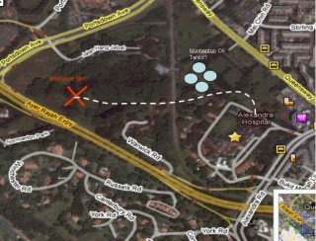
According to John Patridge, the prisoners were herded past the burning
Normanton oil tanks, under the drain beneath the railway track to huts
located some quarter mile away from AH (marked with red cross). Along
the way there, many feeble prisoners fell and were bayoneted by the
Japanese. (Map from sg.shownearby.com)
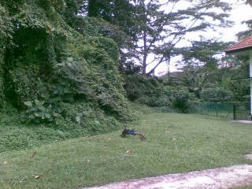
A picture of the dense forest at the end of Warwick Road.
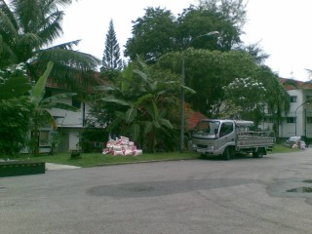
Private colonial-style bungalows along Warwick Road.
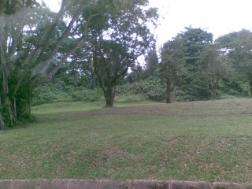
Another view of the forested area beyond the railway tracks
of Alexandra, where the massacre of hospital staff might have taken
place.
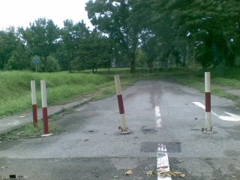
A picture of the stretch of forested area behind Alexandra
Hospital, where the burning Normanton oil tanks were once
located.
Beyond the modern comfort of a newly refurbished Alexandra Hospital, what lurks within the dark forests flanking both sides of the railway tracks? Are the victims of the massacre still roaming around the site of their tragic deaths? Why is huge expanse of forested land undeveloped for more than 60 years after the war in land-scarced SIngapore? As we ponder over these mysteries, business still goes on in the hospital, which was once the pride of a seemingly indestructible British Empire.
Featured picture: A japanese soldier bayoneting his victim to death. More than 200 hospital staff and Officers were killed in this way beyond the railway track of Alexandra. (from "Alexandra Hospital: From British Military to Civilian Institution 1938-1998")
References
"Alexandra Hospital: From British Military to Civilian Institution 1938-1998" by John Patridge.
History of Alexandra Hospital http://www.alexhosp.com.sg/history.asp
sg.shownearby.com
Children (and families) of the Far-east Prisoners of War. http://www.cofepow.org.uk/

