Trump says White House staff had to convince Biden not to release pre-recorded message on Israel and claims Iran would never have attacked if he was president: 'This is no time for a taped speech'
- The former president added that if he was commander in chief 'this would never have happened' in a number of posts made to his Truth Social platform
- He also claimed President Biden had recorded a message to address the nation, which advisers had to convince him not to release
By Joe Hutchison For Dailymail.Com
Published: 20:27 EDT, 13 April 2024

Donald Trump has claimed that White House staff had to convince President Biden not to release a pre-recorded message following attacks on Israel by Iran.
The former president added that if he was commander in chief 'this would never have happened' in a number of posts made to his Truth Social platform.
Trump said: 'Biden's handlers convinced him not to release his taped speech on Israel. He'll now attempt to do it live.'
Another post said: 'Biden, on Israel, didn’t do his “Address to the People” LIVE. He taped it. This is no time for taped speeches!!!'
Unconfirmed reports had circulated shortly after news broke of the Iranian drone attacks that Biden would address the nation live from the Oval Office.
The former president has claimed that White House staff had to convince Biden to not go ahead with a pre-recorded message following the attacks
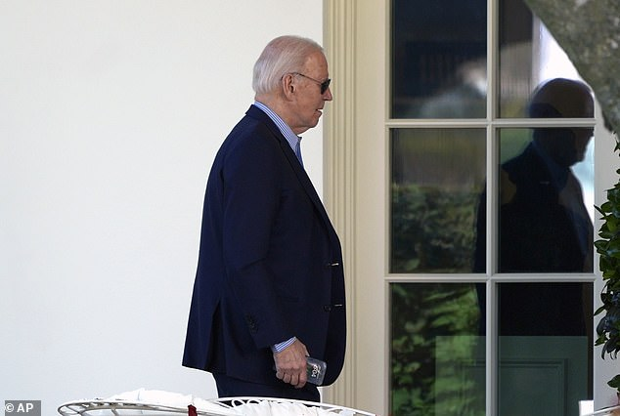
Biden is seen here walking to the Oval Office after returning from Delaware to consult his national security team

