Understanding Australian Identity Discs Part 2 : Second World War, Royal Australian Navy

Dianne Rutherford
24 June 2015
Members of the Royal Australian Navy (RAN) in the First World War were not officially issued with identity discs. However, they were in the Second World War. In June 1939 Commonwealth Navy Order (CNO) 97 ordered that the RAN would follow the Royal Navy procedure laid down in Confidential Admiralty Fleet Order (AFO) 805/1939 that a single red circular compressed fibre disc would be issued to all naval personnel. Not everyone used the red fibre discs however, with some men issued 1907 pattern metal discs left over from the First World War and others wearing improvised identity discs.

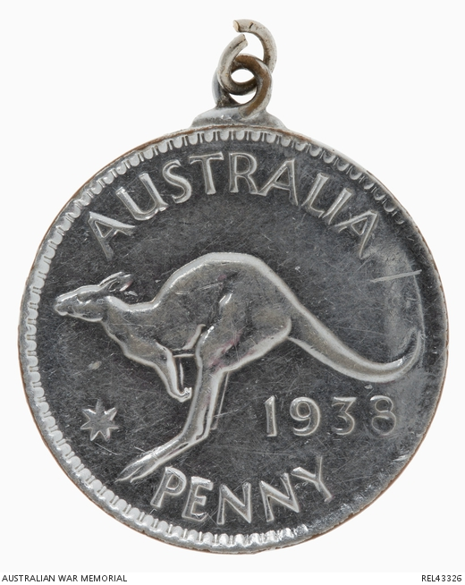

Accession Number: REL43326
Improvised identity disc from an Australian Penny

MARKING DISCS
On the front of rating’s identity discs was stamped name, branch, service number and religion. For officers it was name, rank and religion. On the reverse was blood group.
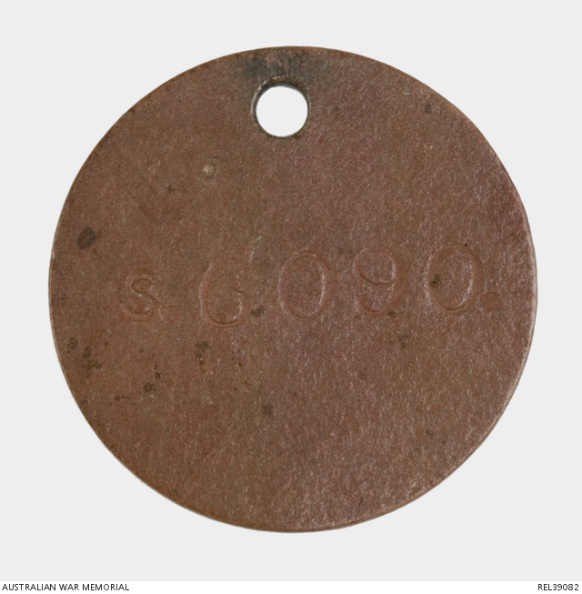

Accession Number: REL39082
Second World War red fibre Navy identity disc.

As is often the case, there is quite a bit of variation in the naming on discs that survive. Some have the blood groups on the front and service number on the back. Some have the names stamped at the top of the disc, others have it around the edges. To give some examples of naming on Navy identity discs, on the front of the one above is recorded "GEO SOUTHWARD" (George Southward - usually discs only record initials for given names, not abbreviations), "B3" for blood type, "CE" for religion (Church of England), "OD" for his rank (Ordinary Seaman) and on the reverse is impressed "S6090" for his service number. On the disc below is recorded "R J REYNOLDS" (Ronald James Reynolds), "TEL" for rank (Telegraphist), "PA2957" for service number and "MOSS 2A" for blood type. There is nothing impressed on the reverse and his religion is absent.
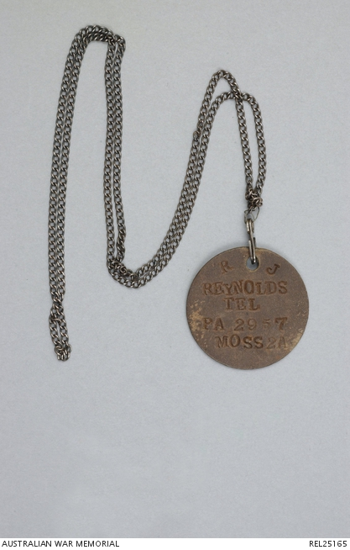
Accession Number: REL25165
This identity disc has the blood types '2A' on the front and includes the blood type system name
BLOOD TYPES
With the introduction of blood transfusions, blood type was usually recorded on the reverse of the identity disc but you do sometimes find it on the front with the other details. The letter and number stamped on the back of identity discs are the combination of two different blood identifications schemes, the Moss System and Landsteiner’s original scheme (International System). The Moss System was a classification of blood groups that labelled blood groups 1 through 4 and the International Scheme used letters we are familiar with today (O, A, AB etc). Using both systems on the discs could speed up transfusions and avoid any adverse reactions. Further information about blood transfusions and the use of the two systems is in Chapter 34 of Australia in the War of 1939-1945: Series 5 - Medical, Volume I - Clinical Problems of War.
BURYING THE DEAD
In Section 11 of CNO411/1942 “BURIAL, GRAVES REGISTRATION, IDENTIFICATION OF BODIES AND BURIAL OF ENEMY DEAD” the importance of identity discs were noted for official identification of the dead: “In addition to confusion in naval records, undue hardship to relatives can be caused through the acceptance of inconclusive evidence of identification of the dead. Estates may have changed hands owing to non-substantial proof of identification, and it cannot be too strongly stressed that the identity disc is the only acceptable conclusive evidence of identification. All personnel should be repeatedly warned against exchanging identity discs. Upon burial the identity disc is not in any circumstances to be removed from the body, but the inscription thereon should be noted on the report of death (Form A.S. 1121)”.
WEARING DISCS
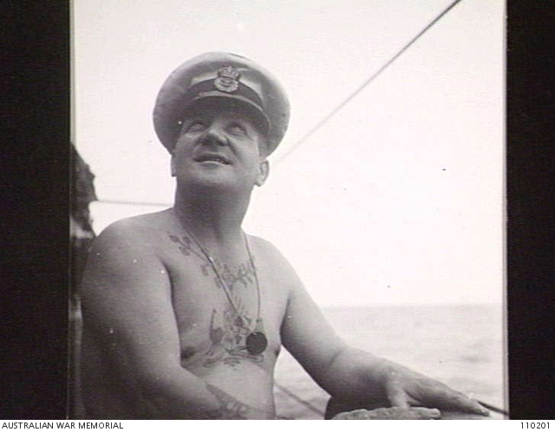
Accession Number: 110201
1945 - a member of the RAN wearing his red compressed fibre identity disc: AT SEA. BORNEO AREA. 22 JUNE 1945. MASTER-AT-ARMS, H S SCALES, RAN, THE SENIOR RATING ABOARD THE RAN CRUISER, HMAS HOBART.
In peace time the disc was wired to the gas respirator containers but with the declaration of war, they were ordered to be worn around the neck on a length of cord. This however, was often not the case and you rarely see RAN personnel in photographs wearing their identity discs. Some of this may be cultural, but there are also practical reasons not to wear an identity disc around your neck when working, particularly with machinery where the cord could get hooked or be in the way. Men not wearing their discs continued to be an issue through the war. In 1942 CNO 330 referred personnel to AFO 2656/1940 directing them to wear their identity discs. Commanding Officers were ordered to “take the necessary steps to endure strict compliance by personnel in future”.
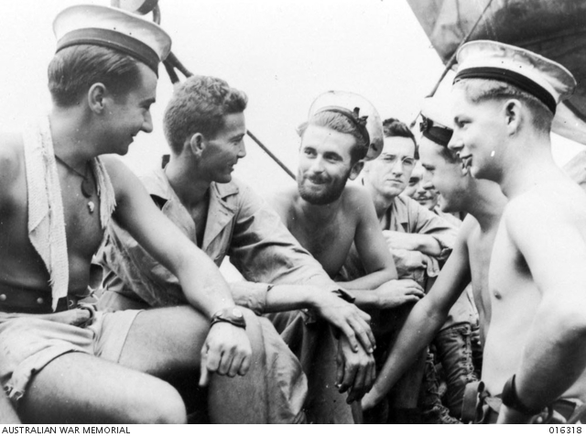
Accession Number: 016318

December 1943. Of the four sailors in this photograph, only one is wearing his identity disc.

